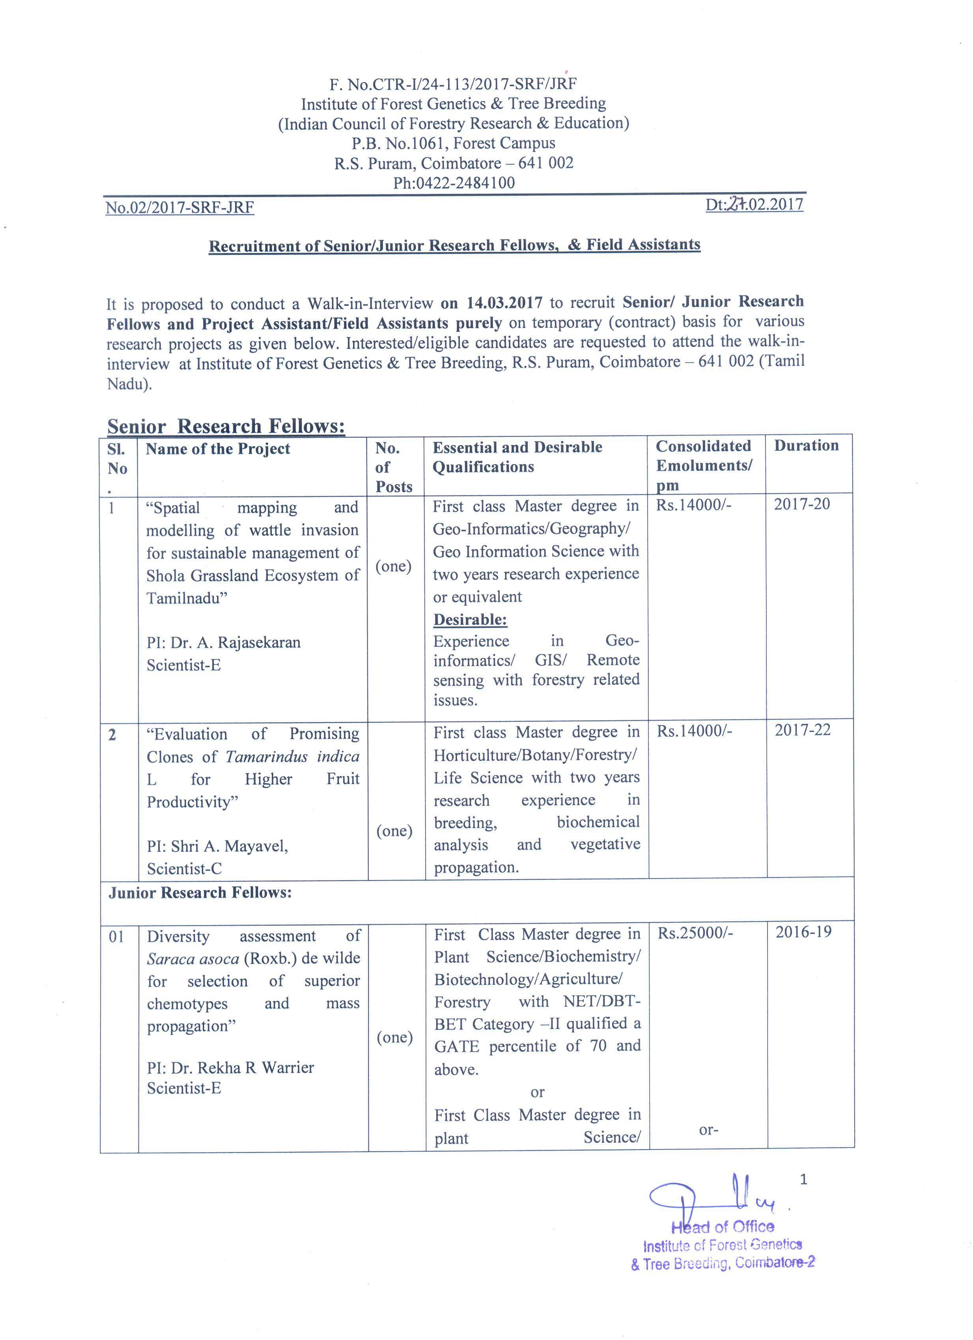
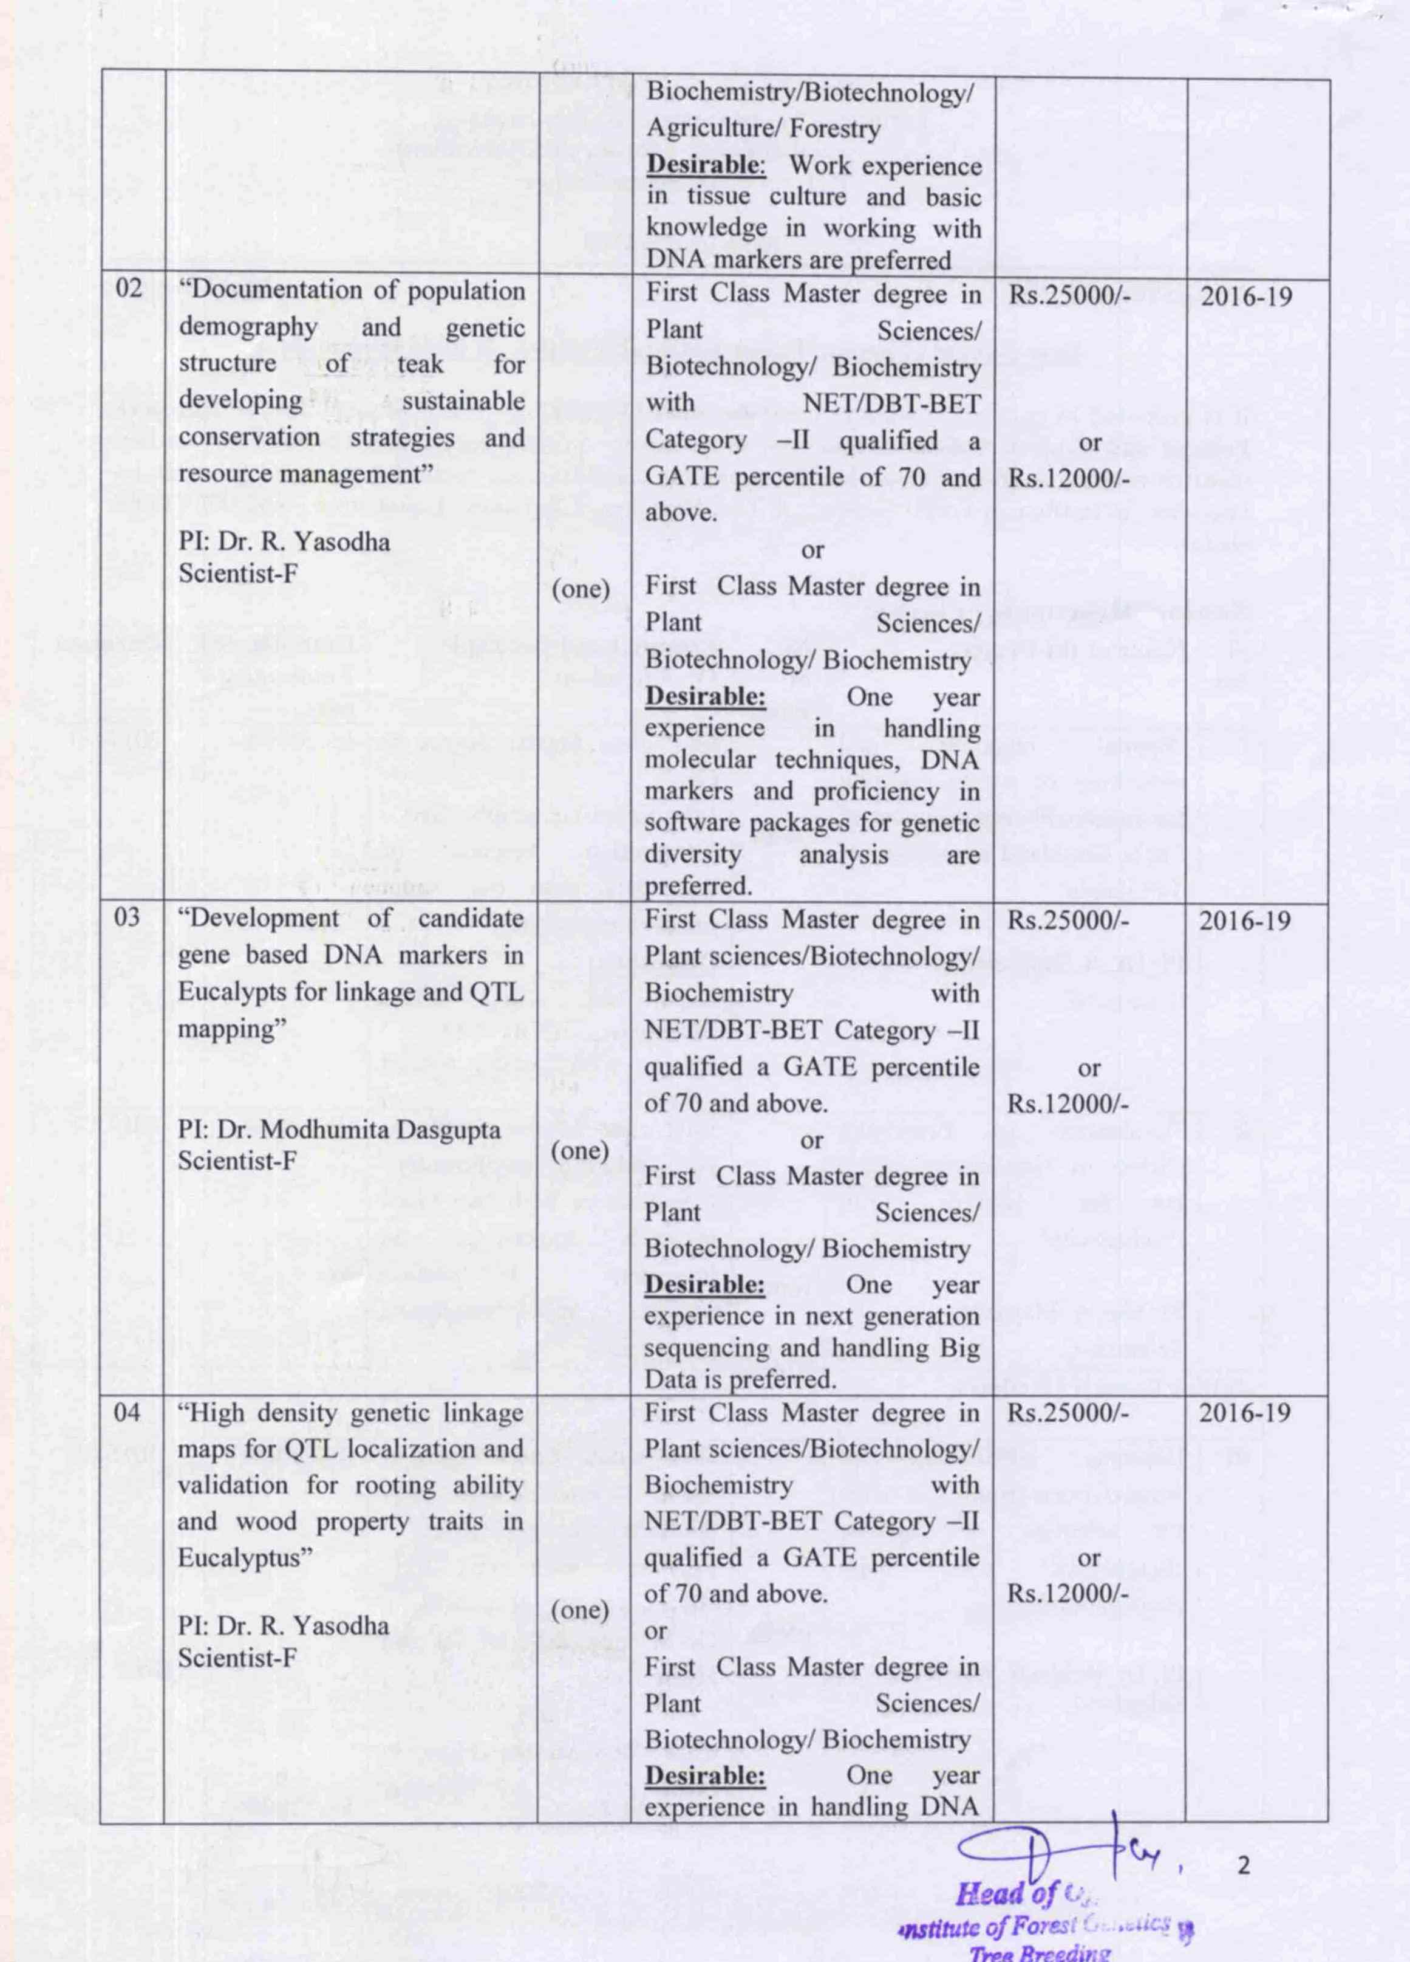
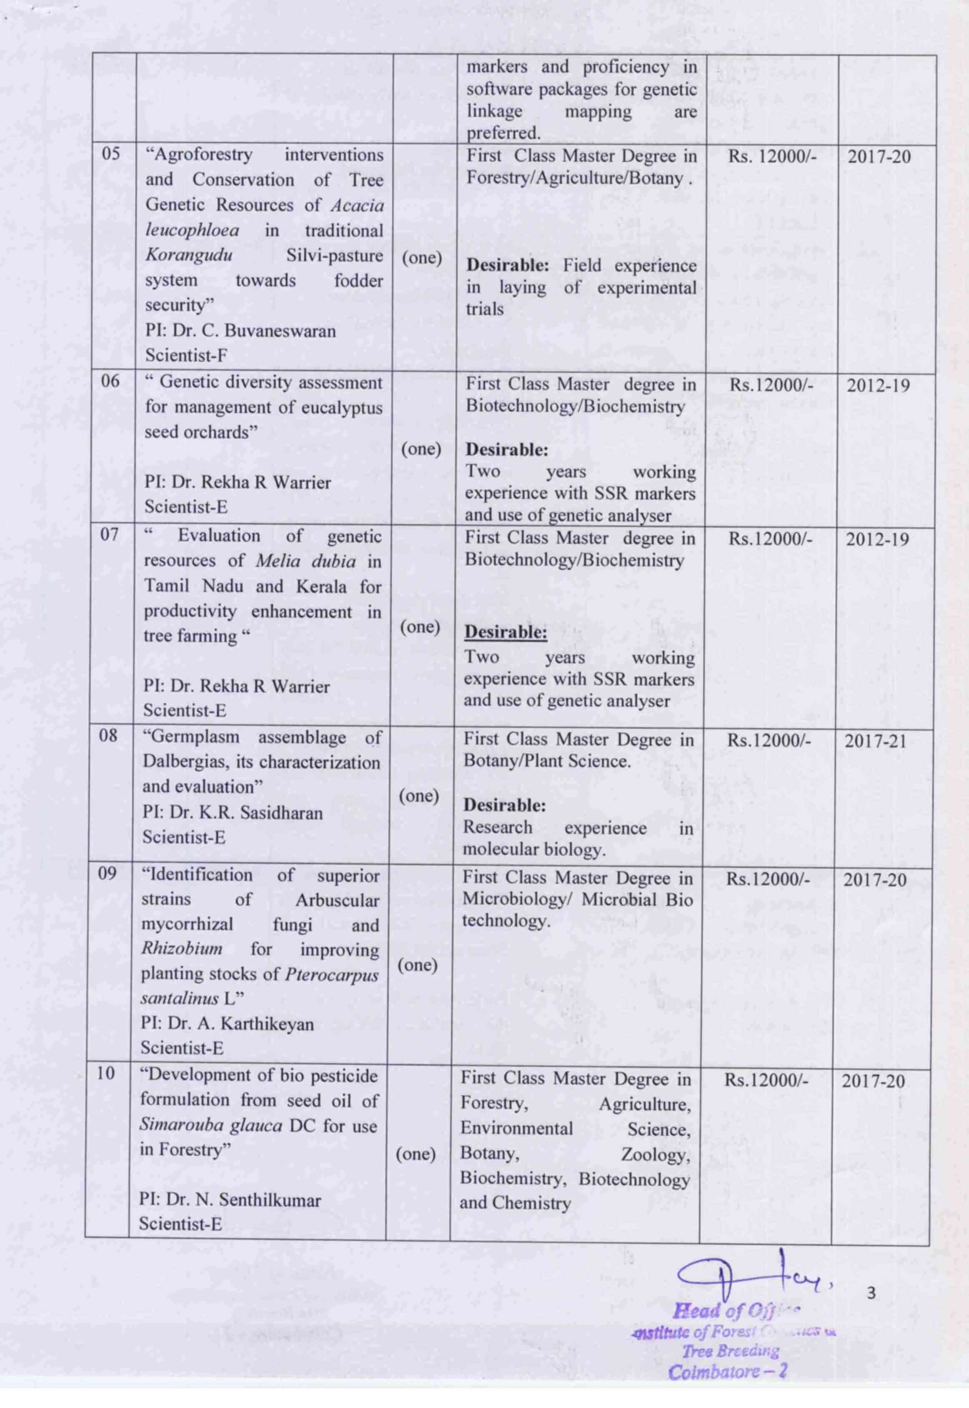
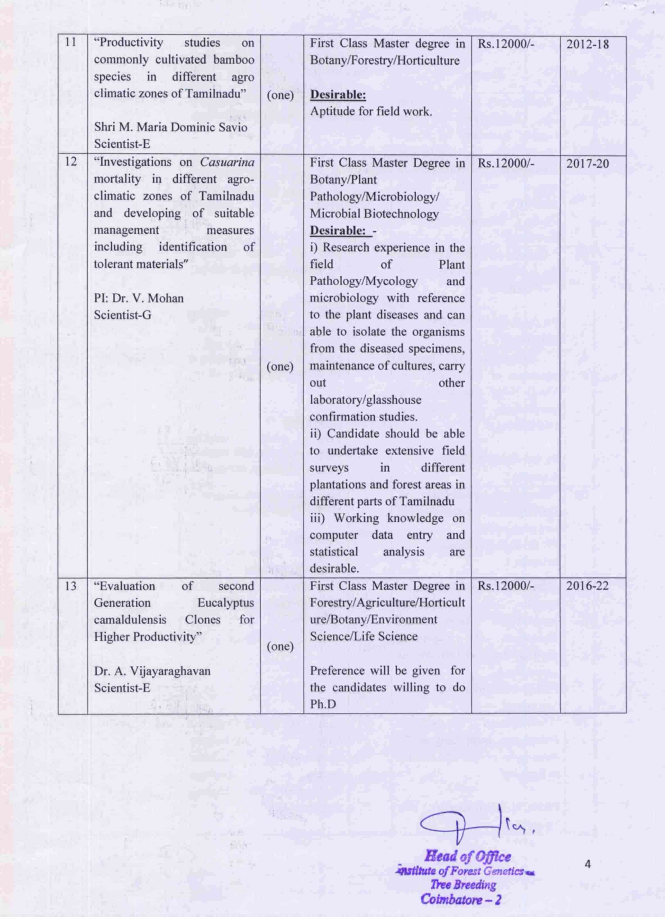
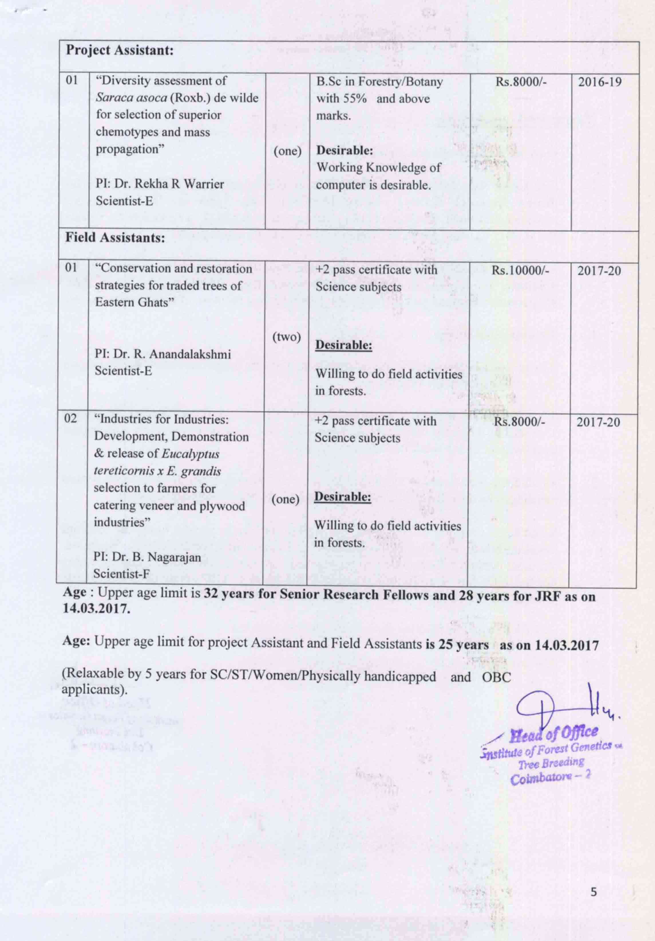
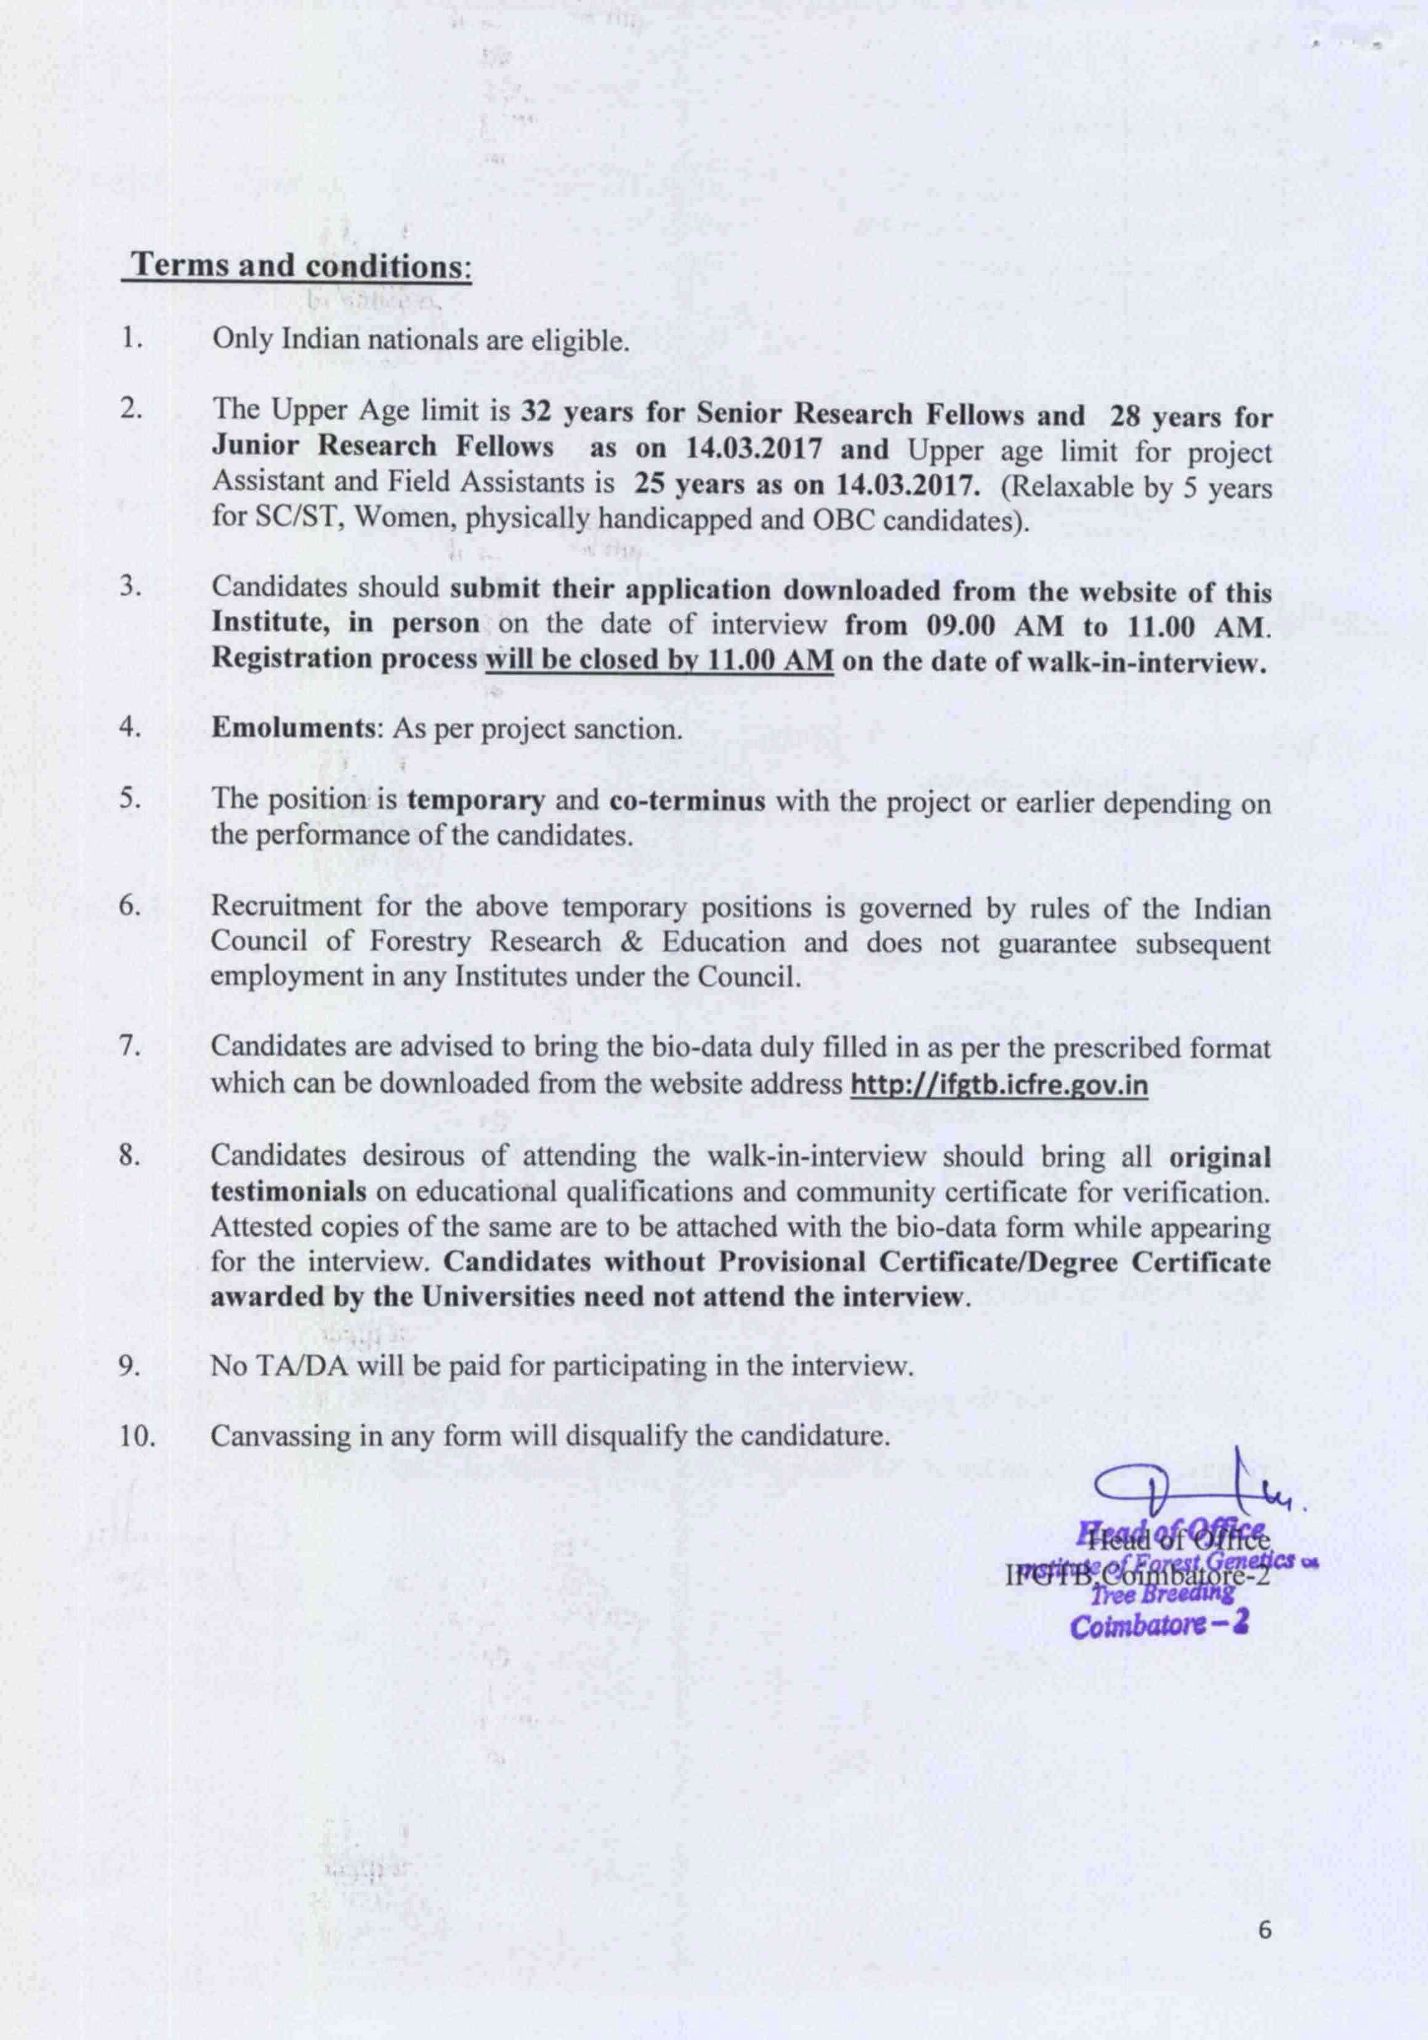
Institute of Forest Genetics & Tree Breeding
(Indian Council of Forestry Research & Education)
(An autonomous body of the Ministry of Environment & Forests, Govt. of India)
P.B. No.1061, Forest Campus
R.S. Puram, Coimbatore – 641 002
Affix Passport size Photograph
------
Application Proforma

1. Advertisement No : 02/2017/SRF-JRF

2. Name of the Position :

3. Name of the Project :

4. Name in Capital Letter :

5. Father’s Name :

6. Date of Birth :

7. Aadhaar No. :

8. Age as on :

9. Sex/Marital Status (√) :
Unmarried
Married
F
M

10. Whether belongs to : SC/ST/OBC/PH

11. Present and Permanent Address with
Telephone/cell No/Email. :

12. Educational Qualification
(attach self attested copies of testimonials) :
Qualification | Institution | University/Board | Year of Passing | Subject | Division/ % of Marks | Specialization
SSLC
HSC/+2
B.Sc
M.SC
Ph.D
NET/DBT-BET/GATE score
Any other

13. Whether receiving Scholarship/Fellowship
From any agency? If yes, indicate :

14. Are you under any contractual obligation to
Serve Central/State Govt/Any other public
Sector Undertaking or Autonomous body and
If so, give details(attach NoC if applicable) :

15. Previous research experience (in bullet points)
(Enclose copies of experience certificate)

16. Publications if any :

17. Any other relevant information :
(not more than 50 wards)

18. Language Proficiency :

19. Name & Address of two references :
(known for a minimum of two years)

Declaration

I hereby declare that the above information is correct and to the best of my knowledge and belief, if I am found to have concealed/distorted any material information, my appointment shall be liable for termination without notice.

Place: Signature of Candidate
Date:

